Request Packet:

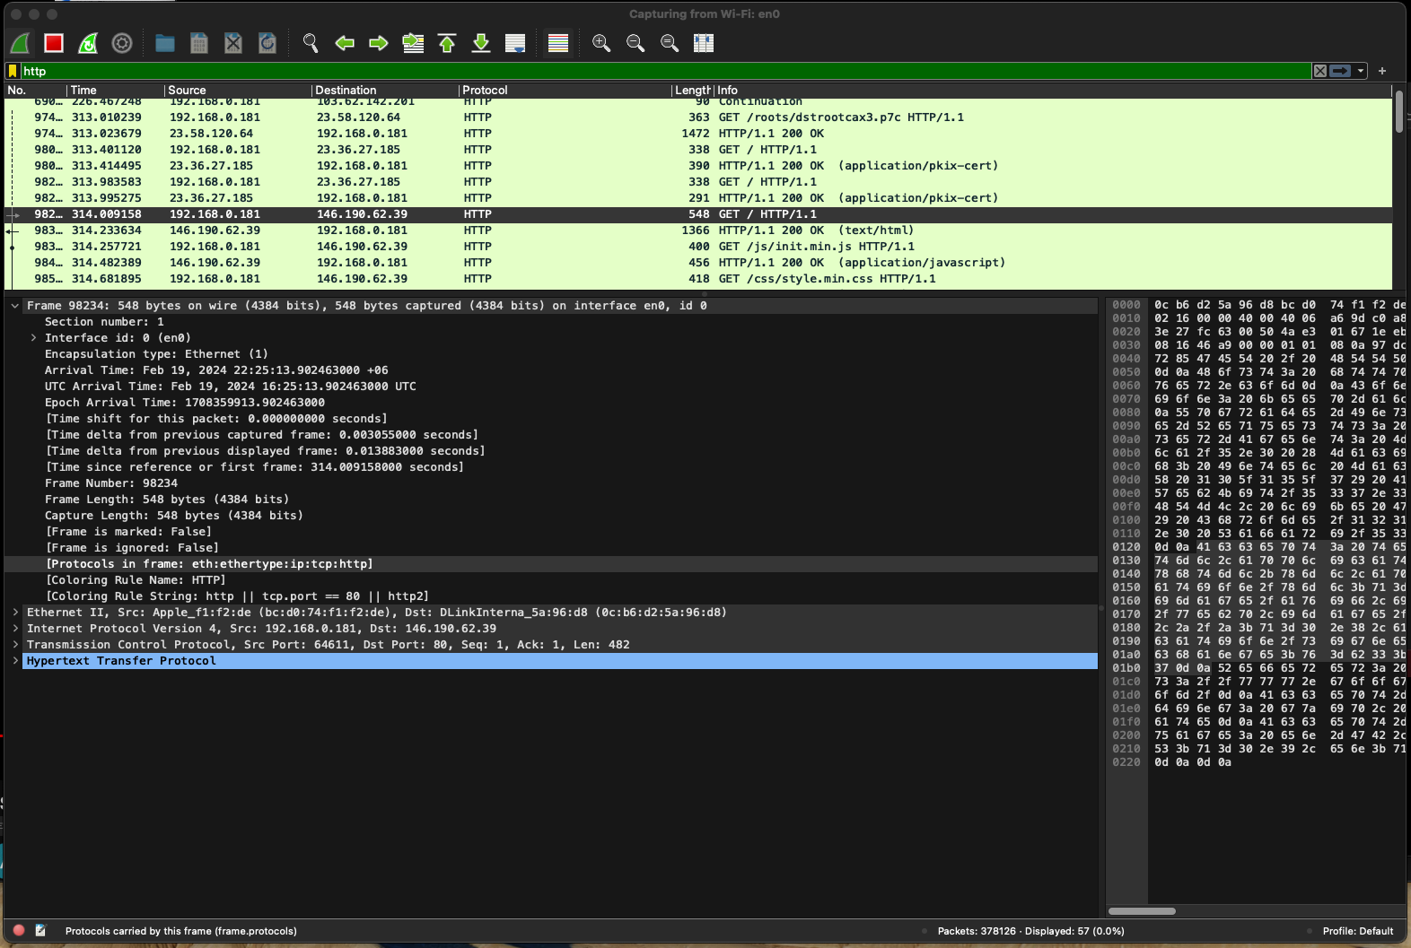

Frame falls under Physical layer

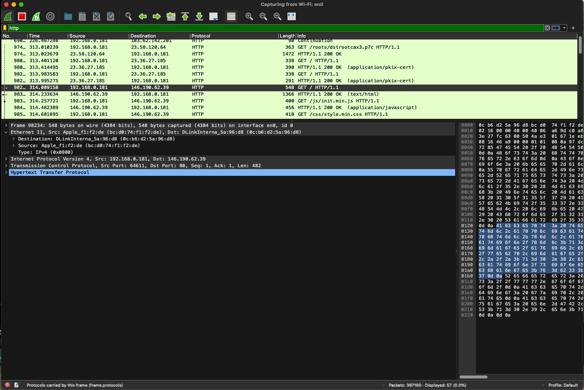

Ethernet II falls under Data Link Layer

This is my destination mac address. (0c:b6:d2:5a:96:d8)

And this is my Source mac address (bc:d0:74:f1:f2:de)

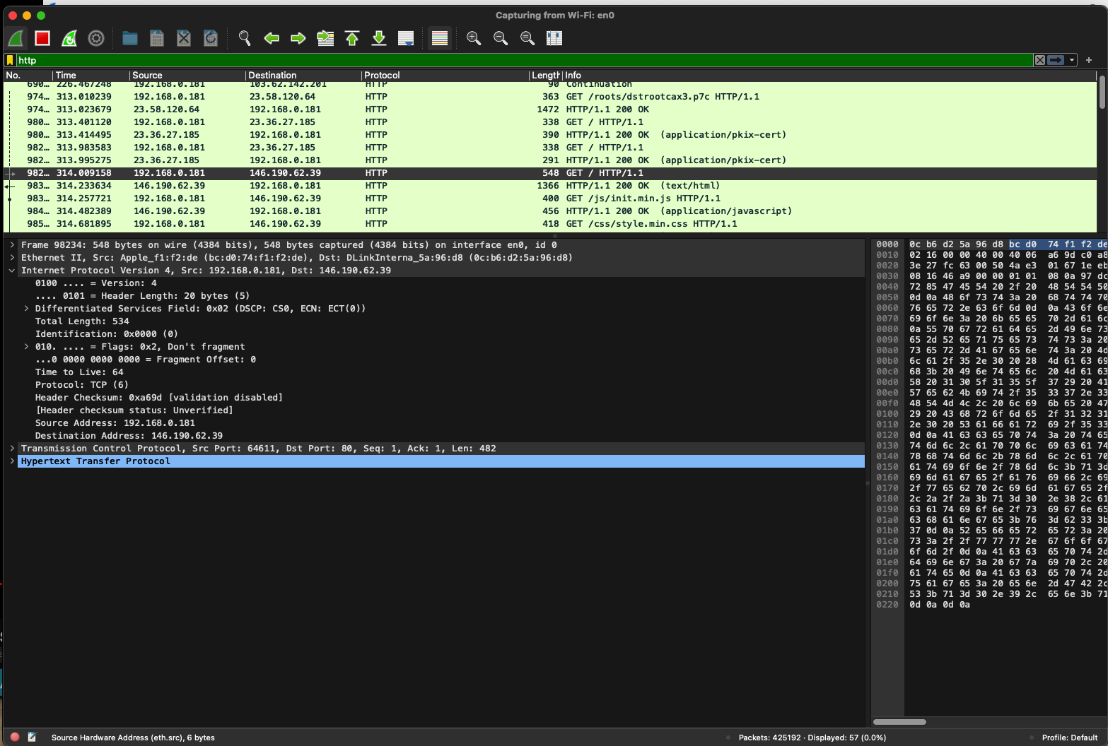

Internet Protocol Version 4 operates in the network layer.

My source IP address is 192.168.0.181, and my destination IP address is 146.190.62.39 which is basically the address of the website I entered on my browser.

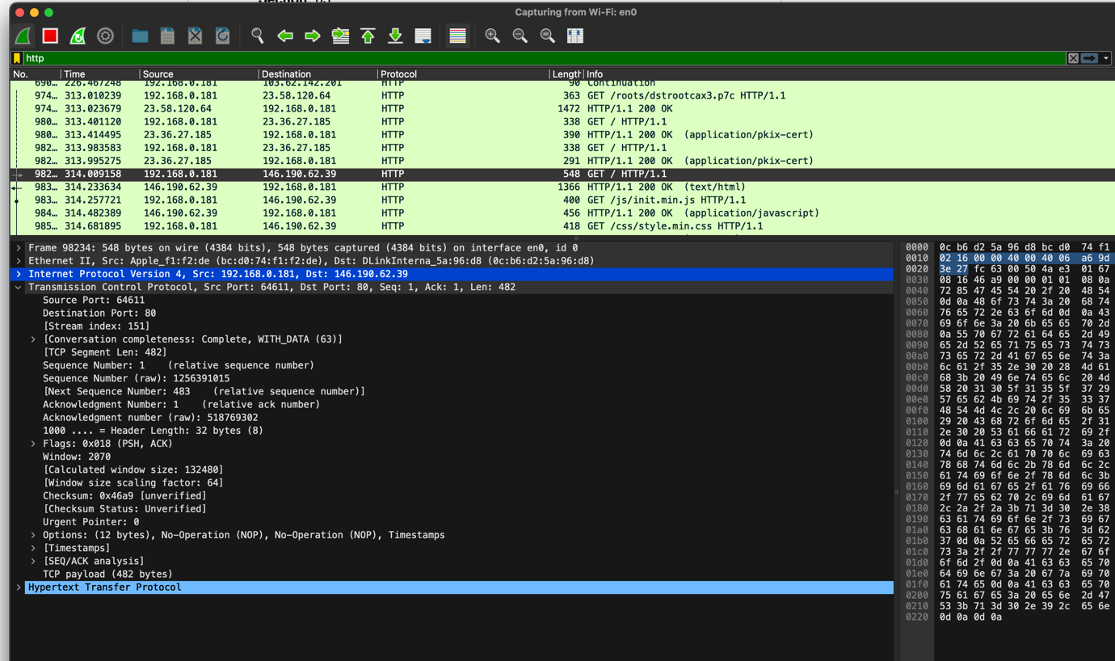

TCP falls under transport layer. The source port is 64611, and the destination port is 80 which is used by HTTP. Furthermore, we can see the sequence number and the acknowledgement number as well. TCP uses three-way handshake to establish a reliable connection and acknowledge both sides of the connection.

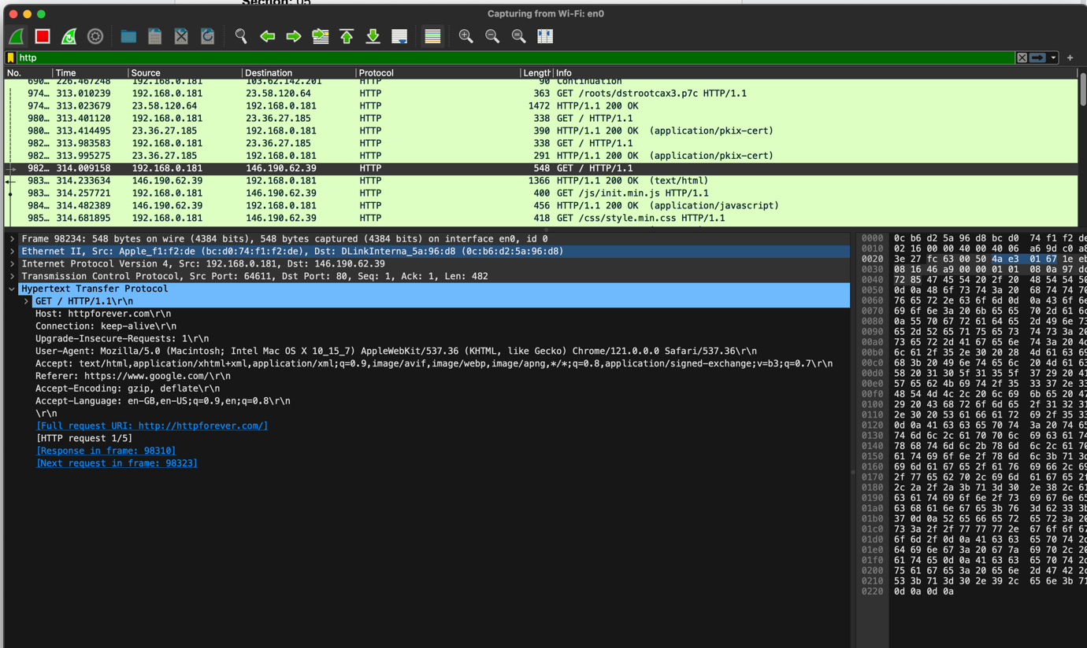

HTTP operates over the application layer, we can see the host is httpforever, which is the website I entered on the address bar of my browser, and in turn, a GET request was sent to that host. The connection is set to keep-alive, which indicates that it is a persistent HTTP connection. Furthermore, we can see the user agent, which shows the browser and the platform used to initiate the GET Request from.

**Response packet**

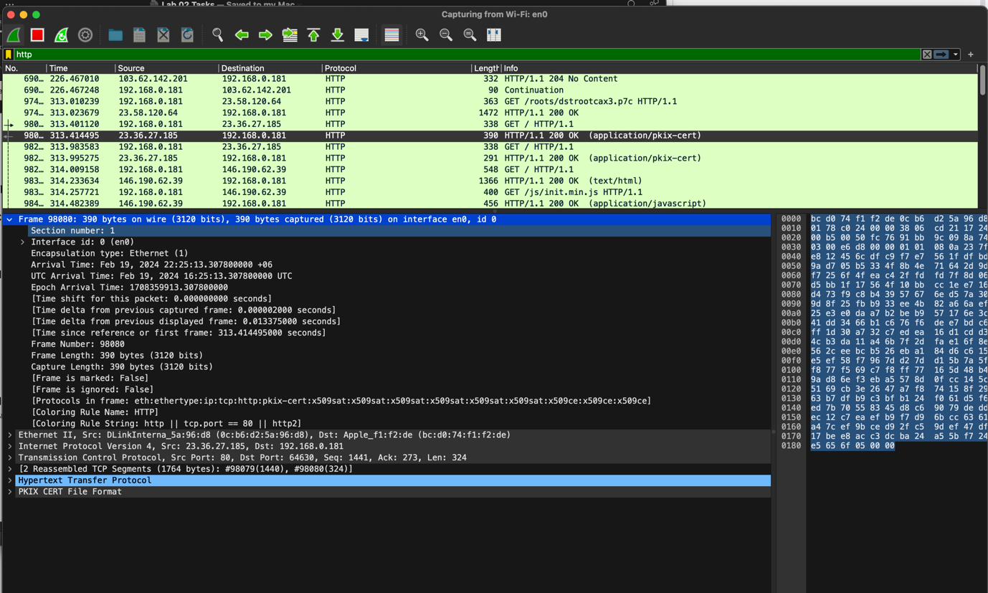

Frame falls under Physical layer

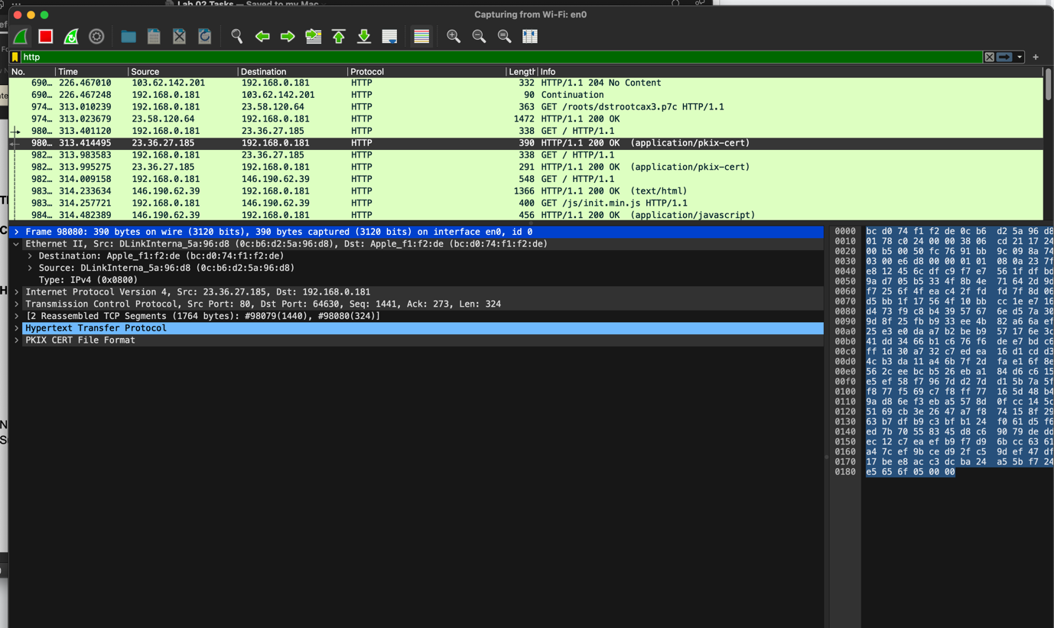

Ethernet II falls under Data Link Layer

This is my source mac address. (0c:b6:d2:5a:96:d8)

And this is my destination mac address (bc:d0:74:f1:f2:de)

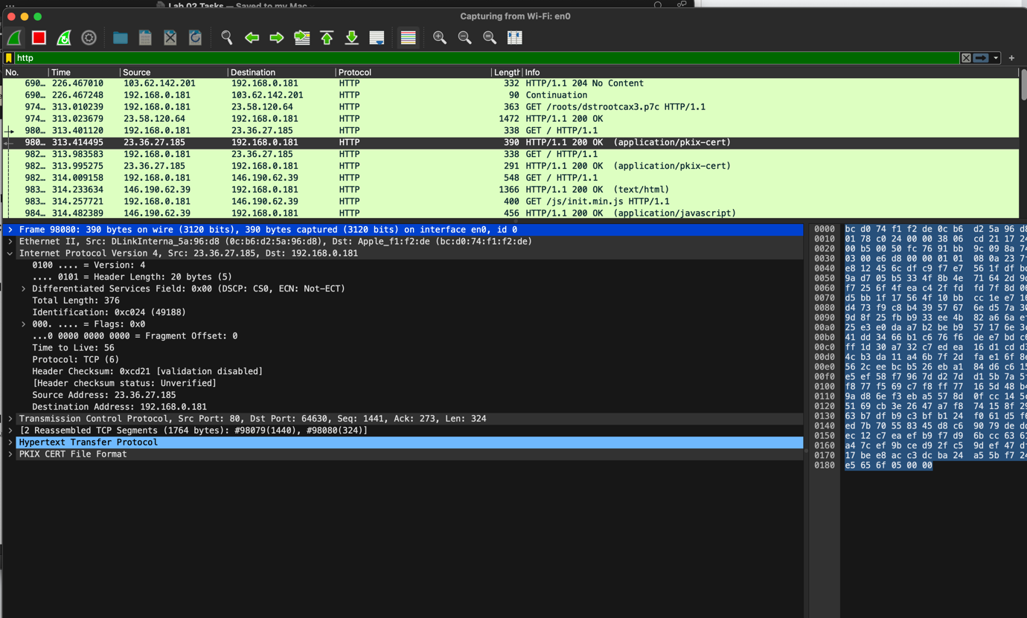

Internet Protocol Version 4 operates in the network layer.

My destination IP address is 192.168.0.181, and my source IP address is 23.36.27.185.

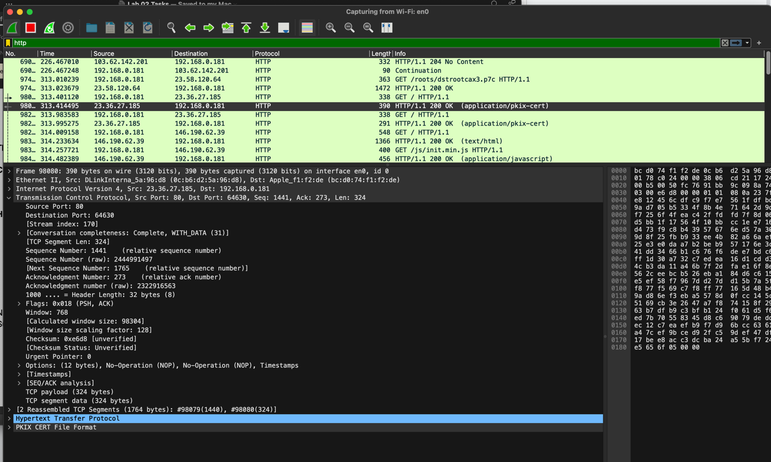

TCP falls under transport layer. The source port is 80, and the destination port is 64630 which is used by HTTP. Furthermore, we can see the sequence number and the acknowledgement number as well. TCP uses three-way handshake to establish a reliable connection and acknowledge both sides of the connection.

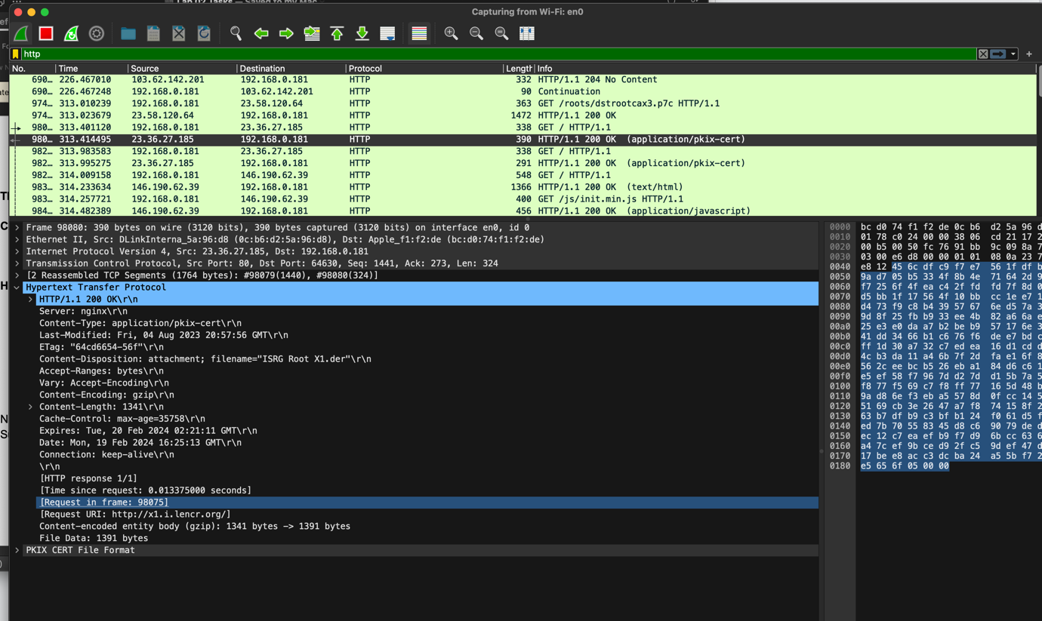

HTTP operates over the application layer, we can see the host is the server, which is the website I entered on the address bar of my browser, and in turn, a response was sent to the client. The connection is set to keep-alive, which indicates that it is a persistent HTTP connection.